

Software Engineering Assignment

# 

# MODULE: 1

## SE – Overview of IT Industry

SUBMITTED BY:

MEMAN ASGAR ALI

SUBMITTED TO:

CHINMAYEEMAM

1. What is software? What is software engineering?

● in Computer System, the software is basically a set of instructions or commands that tell a computer what to do. In other words, the software is a computer program that provides a set of instructions to execute a user’s commands and tell the computer what to do.

# •SOFTWARE ENGINEERING

● Software engineering is the branch of computer science that deals with the design, development, testing, and maintenance of software applications.

2. Explain types of software

●The two main categories of software are system software and application software.

# ● System software

System software. These software programs are designed to run a computer's application programs and hardware. System software coordinates the activities and functions of the hardware and software. In addition, it controls the operations of the computer hardware and provides an environment or platform for all the other types of software to work in. An operating system (OS) is the best example of system software.

# ● Application software

Application software. The most frequently used software is application software, which is a computer software package that performs a specific function for a user or, in

some cases, for another application. An application can be self-contained, or it can be a group of programs that run the application for the user. Ex word ,excel etc…

# ●Driver software

Driver software. Also known as device drivers, this software is often considered a type of system software. Device drivers control the devices and peripherals connected to a computer, helping them perform their specific tasks. Every device that's connected to a computer needs at least one device driver to function.

# ●Middleware

Middleware. The term middleware describes software that mediates between application and system software or between two different kinds of application software.

# ●Programming software

Programming software. Computer programmers use programming software to write code. Programming software and programming languages, such as Java or Python, let developers develop, write, test and debug other software programs. Examples of programming software include assemblers, compilers, debuggers and interpreters.

3. What is SDLC? Explain each phase of SDLC

•The software development lifecycle (SDLC) is the cost-effective and time-efficient process that development teams use to design and build high-quality software.

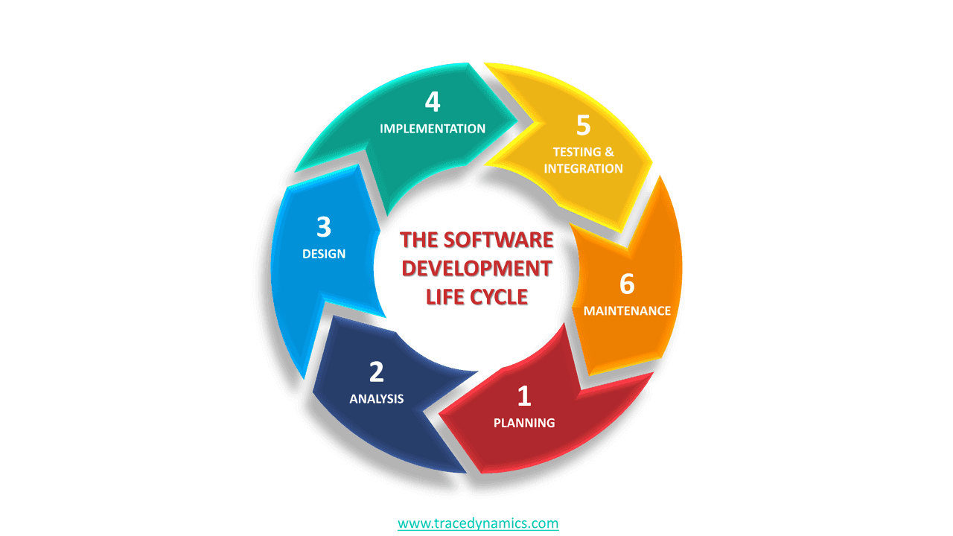

•The SDLC methodology focuses on the following phases of software development:

•Planning

The first phase of the SDLC is the project planning stage where you evaluate the feasibility of creating the product, revenue potential, the cost of production, the needs of the end-users, etc.

•Analysis

This phase involves gathering information about the software requirements from stakeholders, such as customers, end-users, and business analysts

•Design

In this phase, the software design is created, which includes the overall architecture of the software, data structures, and interfaces.

•Implementation

In this phase, the design is then implemented in code, usually in several iterations, and this phase is also called as Development.

•Testing

In this phase, the software is thoroughly tested to ensure that it meets the requirements and works correctly.

•Maintenance

In the maintenance phase, includes ongoing support, bug fixes, and updates to the software.

4. What is DFD? Create a DFD diagram on Flipkart

A data flow diagram (DFD) is a graphical representation of the “flow” of data through an information system, modelling its process aspects. It is a powerful tool used in system analysis and design, and it allows a clear and concise representation of the system’s components, data, and interactions.

## 

## Context Level DFD: 0 Level

## 

## 

## 

## User Side DFD: 1 Level

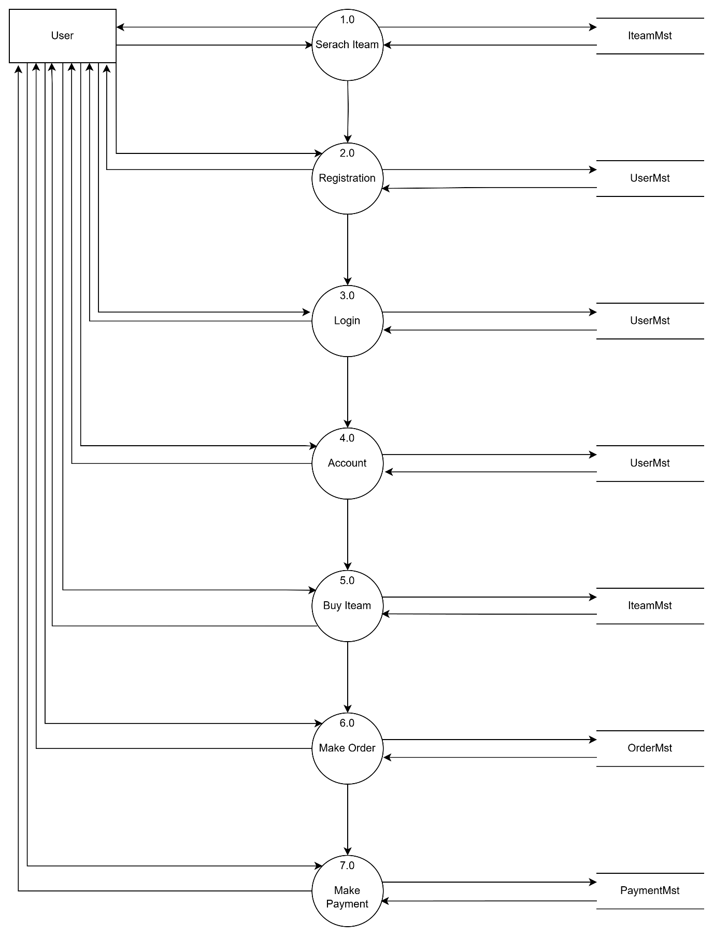

## User Side DFD: 2 Level (4.0)

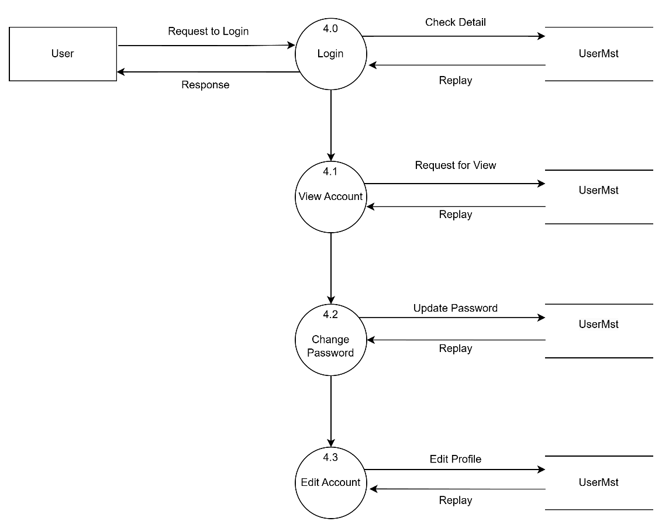

## User Side DFD: 2 Level (5.0)

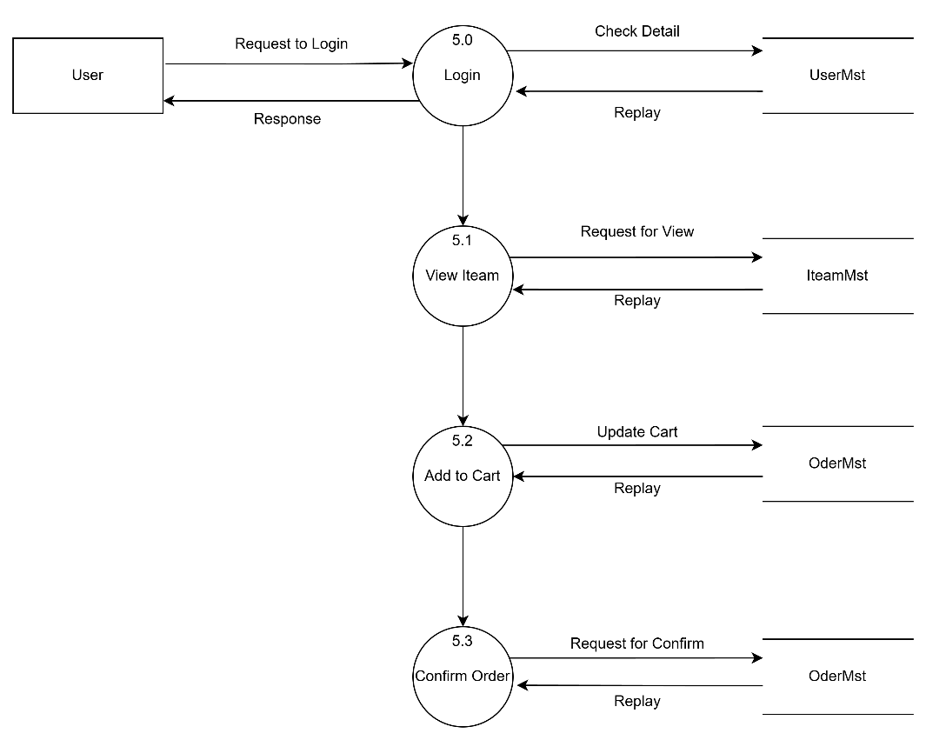

5. What is Flow chart? Create a flowchart to make addition of two numbers

●A flowchart is a type of diagram that represents a workflow or process. A flowchart can also be defined as a diagrammatic representation of an algorithm, a step- by-step approach to solving a task.

# •flowchart to make addition of two numbers

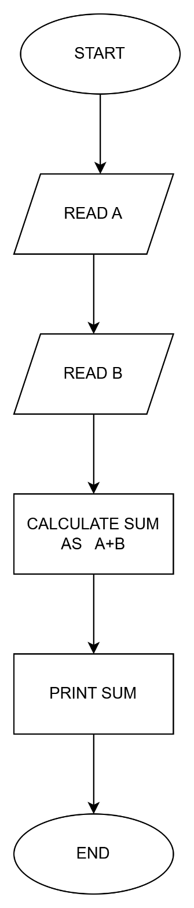

6. What is Use case Diagram? Create a use-case on bill payment on PAYTM.

●A use case diagram is a graphical depiction of a user's possible interactions with a system.

## use-case on bill payment on PAYTM.

